REST ASSURED API TESTING:

Code:

POM FILE:

<project xmlns="http://maven.apache.org/POM/4.0.0" xmlns:xsi="http://www.w3.org/2001/XMLSchema-instance" xsi:schemaLocation="http://maven.apache.org/POM/4.0.0 https://maven.apache.org/xsd/maven-4.0.0.xsd">

<modelVersion>4.0.0</modelVersion>

<groupId>RestassuredTestt</groupId>

<artifactId>RestassuredTestt</artifactId>

<version>0.0.1-SNAPSHOT</version>

<dependencies>

<dependency>

<groupId>io.rest-assured</groupId>

<artifactId>rest-assured</artifactId>

<version>4.3.3</version>

<scope>test</scope>

</dependency>

<dependency>

<groupId>org.testng</groupId>

<artifactId>testng</artifactId>

<version>7.1.0</version>

<scope>test</scope>

</dependency>

<dependency>

<groupId>com.googlecode.json-simple</groupId>

<artifactId>json-simple</artifactId>

<version>1.1.1</version>

</dependency>

</dependencies>

</project>  
   
  

 RestAssuredEx code:

package restAssured;  
  
  
import static io.restassured.RestAssured.get;  
import static io.restassured.RestAssured.given;  
  
import org.testng.Assert;  
import org.testng.annotations.Test;  
  
import io.restassured.response.Response;  
  
public class  RestAssuredEx {  
@Test  
void test1() {  
//Response response = RestAssured.get("<https://reqres.in/api/users?page=2>");  
Response response = get("<https://reqres.in/api/users?page=2>");  
System.out.println(response.asString());  
System.out.println(response.getBody().asString());  
System.out.println(response.getStatusCode());  
System.out.println(response.getStatusLine());  
System.out.println(response.getHeader("content-type"));  
  
int statuscode = response.getStatusCode();  
Assert.assertEquals(statuscode, 200);  
}  
@Test  
void test2() {  
given().get("<https://reqres.in/api/users?page=2>").then().statusCode(200);  
}  
  
}

OUTPUT:

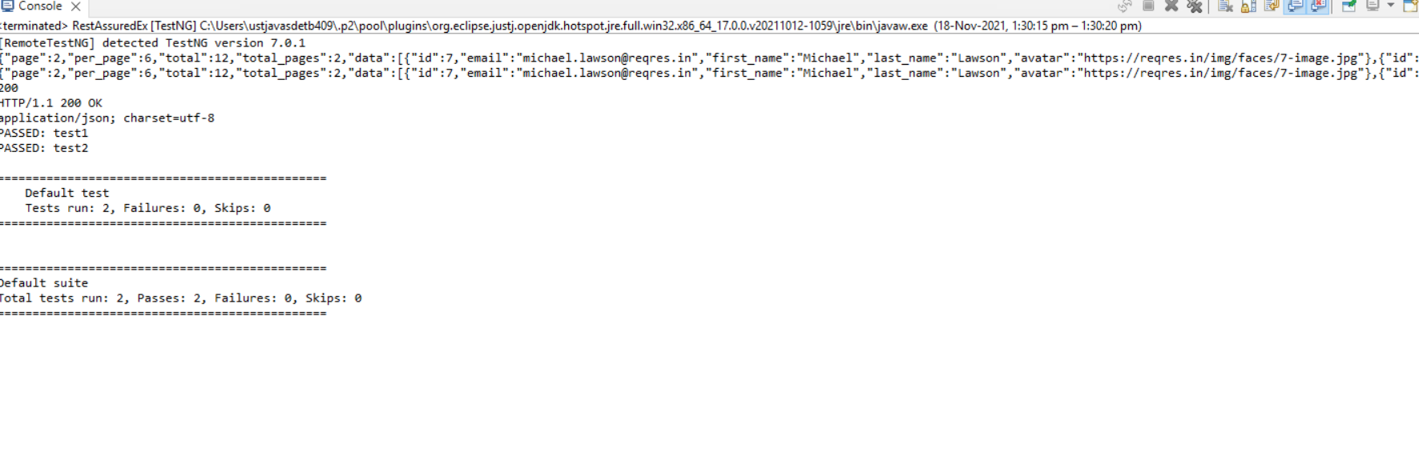

GET CODE:

import static org.hamcrest.CoreMatchers.equalTo;

import static org.hamcrest.CoreMatchers.hasItems;

import org.testng.annotations.Test;

import static io.restassured.RestAssured.*;

public class Tests_GET {

@Test

public void test_1() {

given()

.get("https://reqres.in/api/users?page=2")

.then()

.statusCode(200);

//print all the data

given()

.get("https://reqres.in/api/users?page=2")

.then()

.statusCode(200).log().all();

//verify something in body

given()

.get("https://reqres.in/api/users?page=2")

.then()

.statusCode(200)

.body("data.email[1]", equalTo("lindsay.ferguson@reqres.in"));

//chech the firs name

given()

.get("https://reqres.in/api/users?page=2")

.then()

.statusCode(200)

.body("data.first_name",hasItems("Michael","Lindsay","Tobias"));

}

}

OUTPUT:

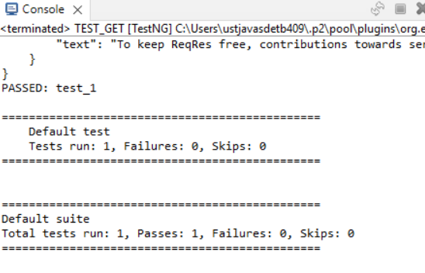

POST CODE:

import static io.restassured.RestAssured.given;

import org.json.simple.JSONObject;

import org.testng.annotations.Test;

import io.restassured.http.ContentType;

public class Tests_POST {

@Test

public void test_1_post() {

// Map<String, Object> map = new HashMap<String, Object>();

// map.put("name", "raghav");

// map.put("job", "Trainer");

// System.out.println(map);

//

// JSONObject request = new JSONObject(map);

JSONObject request = new JSONObject();

request.put("name", "raghav");

request.put("job", "Trainer");

System.out.println(request);

System.out.println(request.toJSONString());

given().

header("content-type","application/json").

contentType(ContentType.JSON).

accept(ContentType.JSON).

body(request.toJSONString()).

when().

post("https://reqres.in/api/users").

then().

statusCode(201);

}

}

OUTPUT:

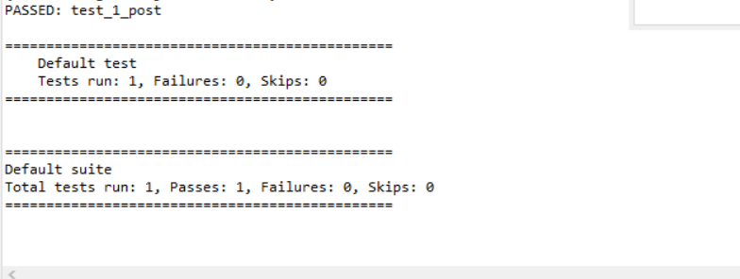

PUT CODE:

import static io.restassured.RestAssured.given;

import org.json.simple.JSONObject;

import org.testng.annotations.Test;

import io.restassured.http.ContentType;

import static io.restassured.RestAssured.*;

public class Tests_PUT {

@Test

public void test_1_put() {

JSONObject request = new JSONObject();

request.put("name", "raghav");

request.put("job", "Trainer");

System.out.println(request);

System.out.println(request.toJSONString());

given().

header("content-type","application/json").

contentType(ContentType.JSON).

accept(ContentType.JSON).

body(request.toJSONString()).

when().

put("https://reqres.in/api/users/2").

then().

statusCode(200).log().all();

}

}

OUTPUT:

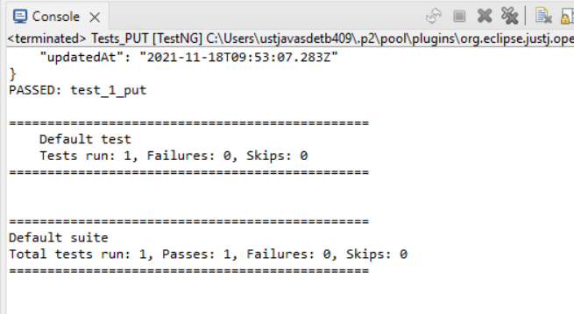

PATCH CODE:

import static io.restassured.RestAssured.given;

import org.json.simple.JSONObject;

import org.testng.annotations.Test;

import io.restassured.http.ContentType;

public class Tests_PATCH {

@Test

public void test_1_patchS() {

JSONObject request = new JSONObject();

request.put("name", "raghav");

request.put("job", "Trainer");

System.out.println(request);

System.out.println(request.toJSONString());

given().

header("content-type","application/json").

contentType(ContentType.JSON).

accept(ContentType.JSON).

body(request.toJSONString()).

when().

patch("https://reqres.in/api/users/2").

then().

statusCode(200).log().all();

}

}

OUTPUT:

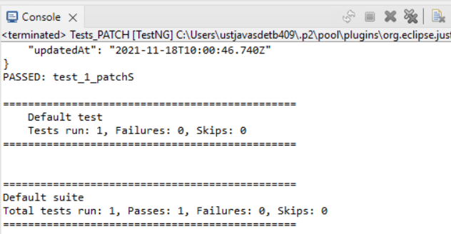

DELETE CODE:

import org.testng.annotations.Test;

import static io.restassured.RestAssured.*;

public class Tests_DELETE {

@Test

public void test_1_Delete() {

when().delete("https://reqres.in/api/users/2").

then().statusCode(204).log().all();

}

}

OUTPUT:

